Field Testing Report
NAME: | MUHAMMAD AFIQ BIN MOHD NIZAM | MATRIC NO: | 300504
PROJECT TITLE: | NLP-BASED SENTIMENT ANALYSIS MENTAL HEALTH CHATBOT
SUPERVISOR: | ROHAYA BINTI DAHARI@DAMIRI

- OVERVIEW OF THE SYSTEM/ APPLICATION
Solace is a bilingual (English and Malay) mental health support chatbot designed to provide empathetic, non-judgmental conversational support to individuals experiencing emotional distress. The system operates through a web-based interface and is powered by a fine-tuned BERT-based emotion classification model integrated with a locally hosted Large Language Model (LLM) — Llama 3.2 via Ollama — for response rephrasing and personalisation.
The chatbot classifies user input into four emotional categories: Anxiety, Depression, Suicidal, and Normal/Neutral. Based on the detected emotion and confidence score, Solace generates contextually appropriate, empathetic responses. For high-risk (suicidal) inputs, the system immediately surfaces Malaysian crisis hotline resources (Talian Kasih: 15999; Befrienders KL: 03-76272929). The system supports both English and Malay input, with automatic language detection and response generation in the user's language.
The frontend is a lightweight web application (HTML, CSS, JavaScript) communicating with a Python Flask backend via a REST API. The backend incorporates two models: a primary fine-tuned emotion classifier for detecting emotional states, and a secondary DistilBERT-based suicide detection model trained on a dedicated Suicide Detection dataset.

- EVALUATION METHOD
This field testing employed two complementary evaluation approaches:
- User Acceptance Testing (UAT) — to assess whether the system meets user requirements and is suitable for real-world use from the end-user perspective.
- Usability Evaluation — to assess the ease of use, interaction quality, and overall user experience of the Solace chatbot interface.
Both evaluations were conducted simultaneously using a structured post-interaction questionnaire administered via Google Form.

Link of the Google Form: https://forms.gle/SBZvRb1JwpzP5TNs8

2.1 Objective of the Evaluation

The objectives of this field testing evaluation were as follows:
- To assess whether Solace accurately detects and responds appropriately to different emotional states expressed in both English and Malay.
- To evaluate the overall usability and user experience of the Solace web interface.
- To determine user acceptance of the chatbot as a mental health support tool.
- To identify functional deficiencies, misclassification cases, and areas requiring improvement before potential deployment.
2.2 Participants
To gauge user comfort and trust in interacting with an AI-based mental health support chatbot.

A total of 20 participants were recruited for this study. Participants were drawn from two primary groups:
- University students from Universiti Utara Malaysia (UUM) — representing the primary target user group for the system.
- Members of the general public — to obtain a broader perspective beyond the academic population.
Participants were recruited through a convenience sampling approach, via personal outreach and sharing of a participation invitation link through social media platforms and messaging groups. No prior experience with mental health chatbots was required. Participants were required to be able to converse in either English or Malay (or both). Demographic information (gender, age group, academic background) was collected as part of the questionnaire preamble.

2.3 Materials

The following instruments and tools were used during the field testing:
# | Material | Description
1 | Solace Web Application | The system prototype accessible via a local web server (Flask backend + HTML/CSS/JS frontend). Participants interacted with Solace through a standard web browser.
2 | Google Form Questionnaire | A structured post-interaction questionnaire with Likert-scale items (1 = Strongly Disagree to 5 = Strongly Agree) assessing usability, response quality, emotional appropriateness, language accuracy, and overall acceptance.
3 | Scenario-Based Interaction Prompts | Participants were provided with example scenarios (e.g., expressing anxiety, sadness, or neutral statements in both languages) to ensure consistent interaction across participants.
4 | Informed Consent Form | A brief online consent form included at the start of the Google Form, informing participants about the study purpose and data usage.

2.4 Procedure for Conduction the Evaluation

The evaluation was conducted using the following step-by-step procedure:
Step 1 — Briefing: Participants were briefed (verbally or via an introductory text in the Google Form) on the purpose of the study, the nature of Solace, and what they were expected to do.
Step 2 — Consent: Participants acknowledged and agreed to the informed consent statement before proceeding.
Step 3 — Interaction Session: Participants interacted with the Solace chatbot for approximately 5–10 minutes. They were encouraged to type messages in both English and Malay and to explore different emotional contexts (e.g., expressing stress, sadness, or simply greeting the bot).
Step 4 — Observation: For in-person testing sessions, the researcher observed participant interactions to note any confusion, errors, or notable reactions without interfering.
Step 5 — Questionnaire Completion: After the interaction, participants completed the Google Form questionnaire. The form covered: demographics (age, gender, education level), usability dimensions, response quality, bilingual performance, user acceptance, and open-ended feedback.
Step 6 — Data Collection: All responses were automatically recorded in Google Sheets via the connected Google Form for subsequent analysis.

- RESULTS AND FINDINGS
3.1 Descriptive Statistics
The following table summarises the mean scores for each evaluation dimension, based on a 5-point Likert scale (1 = Strongly Disagree, 5 = Strongly Agree):
Section A: Usability (Interface & Navigation)
# | Question | Mean | SD
U1 | The chatbot interface is visually clear and easy to understand. | 4.70 | 0.66
U2 | Navigation within the chatbot is simple and intuitive. | 4.63 | 0.68
U3 | The chatbot layout (text, buttons, responses) is well-organized. | 4.65 | 0.67
U4 | The design is user-friendly for first-time users. | 4.65 | 0.67
 | Group Mean | 4.66 | 0.66

Section B: Functionality (Features & Capability)
# | Question | Mean | SD
F1 | The chatbot responds appropriately to my inputs. | 4.40 | 0.75
F2 | The chatbot can handle different types of user queries. | 4.40 | 0.75
F3 | The chatbot provides relevant suggestions or responses. | 4.35 | 0.81
F4 | The sentiment detection feature works during interaction. | 4.45 | 0.76
F5 | The chatbot can guide users when they feel confused or stuck. | 4.55 | 0.69
 | Group Mean | 4.43 | 0.74

Section C: Accuracy (Sentiment & Response Quality)
# | Question | Mean | SD
A1 | The chatbot correctly understands my messages. | 4.65 | 0.67
A2 | The sentiment analysis reflects my actual emotions. | 4.60 | 0.75
A3 | Responses provided are relevant to my situation. | 4.55 | 0.76
A4 | The chatbot gives consistent responses for similar inputs. | 4.60 | 0.75
A5 | I trust the chatbot's responses. | 4.60 | 0.68
 | Group Mean | 4.60 | 0.71

Section D: Performance (Speed & Stability)
# | Question | Mean | SD
P1 | The chatbot responds quickly. | 4.80 | 0.62
P2 | There are no noticeable delays during interaction. | 4.80 | 0.62
P3 | The system runs smoothly without crashing. | 4.80 | 0.62
 | Group Mean | 4.80 | 0.62
3.2 User Acceptance Results
Three binary (Yes/No) questions assessed overall user acceptance:
Acceptance Question | Yes | No
Are you satisfied with the overall experience? | 19 (95.0%) | 1 (5.0%)
Would you use this system in real-life situations? | 14 (70.0%) | 6 (30.0%)
Would you recommend this system to others? | 17 (85.0%) | 3 (15.0%)

The results indicate strong overall satisfaction (95%) and recommendation intent (85%). However, real-life adoption was lower at 70%, suggesting that while participants found the system valuable, some reservations remain regarding its readiness for everyday use.
3.3 Open-Ended Feedback Summary
Participants' improvement suggestions were grouped into the following themes:
Theme | Representative Suggestions
More natural/human-like responses | "Make it more human-response like ChatGPT", "response terlalu macam robot", "boleh berborak macam AI lain seperti ChatGPT"
Response quality improvements | "fix response", "Make response better", "improve accuracy"
New features | "Make voice feature", "Make suggestions", "Buat boleh simpan history (save chat history)"
Interface improvements | "Interface"
No suggestions / Satisfied | "good", "nothing", "no suggestion"

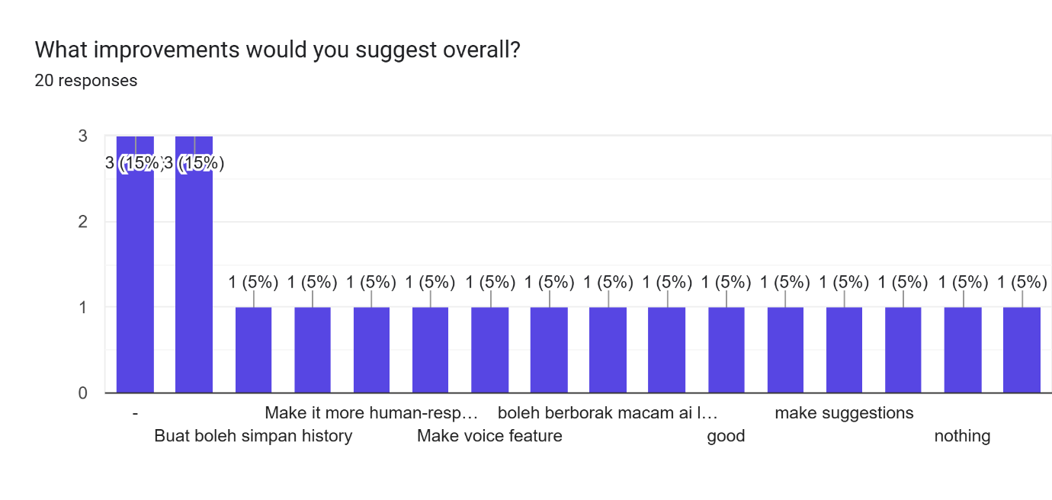

- IMPLICATION OF THE RESULTS
The evaluation results indicate that while Solace demonstrates a promising foundation as a bilingual mental health support chatbot, significant improvements are required before the system can be considered ready for real-world deployment.
4.1 Strengths Identified
- The system successfully differentiates between emotional categories (Anxiety, Depression, Normal) for clear, well-phrased input, demonstrating that the NLP pipeline is functionally sound.
- The web-based interface is accessible and easy to use, suggesting the frontend design meets basic usability standards.
- The safety mechanism for suicidal intent is an appropriate and critical feature of the system.
4.2 Areas Requiring Significant Improvement
Issue | Recommendation
Misclassification of ambiguous or short inputs | Expand the training dataset, particularly for informal Malay and code-switched (Manglish) expressions.
Bilingual response consistency | Improve the language detection module to better handle mixed-language inputs; refine LLM prompting for Malay-specific cultural nuances.
Conversation flow and depth | Implement persistent conversation history and context tracking across sessions for more coherent, multi-turn dialogue.
Generic responses at low confidence | Improve the fallback strategy when the model has low confidence, rather than reverting to a single generic clarification prompt.
User interface enhancements | Add chat history persistence, typing indicators, and the ability to restart or clear conversations from the UI.
Model robustness | Retrain the emotion classifier with a larger, more balanced, and linguistically diverse dataset covering more nuanced mental health expressions.
4.3 Overall Readiness Assessment
Based on the field testing outcomes, Solace is not yet ready for public deployment in its current form. The system shows functional promise, but requires substantive improvements in classification accuracy, bilingual support robustness, and conversational coherence before it can be responsibly used as a mental health support tool for the general public. Further iterative development and a follow-up evaluation round are strongly recommended

Declaration

I hereby declare that this submission is my own work and to the best of my knowledge it contains no materials previously published or written by another.

Afiq |  | 27/5/2026
Student’s Signature |  | Date

Supervisor’s Approval

Project Supervisor’s Signature & Stamp |  | Date

Lecturer’s Approval

Approve without modification
Approve with modification
Reject

Remark:
___________________________________________________________________
___________________________________________________________________
___________________________________________________________________
___________________________________________________________________

Lecturer’s Signature & Stamp |  | Date

